Press release

Jaromír Kallista, producer of Faust and Little Otik and famous Laterna Magika plays, will be inducted into the Producer's Hall of Fame at the Karlovy Vary IFF

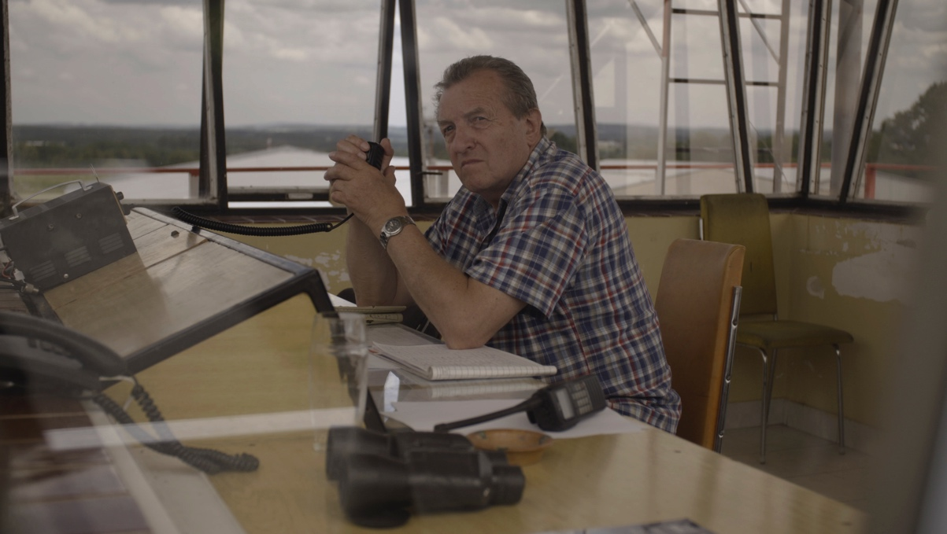
Producer Jaromír Kallista

Švankmajer's legendary films such as Faust (1994), Little Otik (2000), and Lunacy (2005), as well as the famous Laterna Magica production Wonderful Circus (1976) – a prominent Czech producer and executive producer of many Czech New Wave films, Jaromír Kallista stands behind all these significant audiovisual projects. This exceptional personality of Czech film production will be inducted into the Producers' Hall of Fame at this year's 57th Karlovy Vary IFF, that was established last year by the Audiovisual Producers´ Association (APA), which honoured producer Jiří Ježek. The 83-year-old Jaromír Kallista will receive the award from the APA chairman Vratislav Šlayer, actor Jiří Lábus, who starred in Insect, and the head of the Czech Television Film Center Helena Uldrichová, on Sunday, 2 July.

Medallion: https://youtu.be/3k4Gq4yRvzk

"Jaromír Kallista is one of the most original producers in Czech and European film history. With his ability to constantly discover new ways of filmmaking, he has proven that even the most distinctive and artistic film projects can be made on a long-term basis and realized in a sustainable way. His lifelong approach to filmmaking represents the purest definition of independent producing. He has always been willing to share his experience with others, whether as a colleague or as a teacher, and has become an inspiration and mentor to several generations of producers. For all of this, we are deeply grateful to him," says APA chairman Vratislav Šlajer.

Jaromír Kallista had already worked with directors such as Jiří Menzel and Věra Chytilová at FAMU when he produced their graduation films. Kallista's career continued in the 1960s at Army Film, an ambitious production centre of the time, and later at Barrandov Studios. He gained experience working on Jan Schmidt's The End of August at the Ozone Hotel, Kachyňa´s and Procházka's Long Live the Republic, Schorm's cult classic The End of a Priest, and Killing the Devil by Ester Krumbachová. With the onset of “normalisation”, however, he was prevented from working in cinema, the reason being the filming of the events of August 1968 and the "misuse of filmed material for export and for anti-state purposes". The next part of his professional life is inseparably connected with the Laterna Magika multimedia theatre, where he took refuge after the involuntary departure from the Barrandov Film Studio. From 1973 to 1988, he was in charge of production at Laterna Magika and involved in many significant projects, including The Prague Carnival, The Snow Queen and The Night Rehearsal, Black Monk directed by Evald Schorm, One Day in Prague by Ladislav Helge and Vivisection by Antonín Máša. It was at Laterna Magika where his fateful meeting with director Jan Švankmajer and his wife, painter and set designer Eva Švankmajerová, took place. Their first work together was a surrealist film based on the novel Alice in Wonderland called Alice (1988), which was produced with UK and German partners in order to avoid a state monopoly. In 1992, they founded their own film production company, Athanor, which has produced a total of seven films, including Conspirators of Pleasure (1996), Surviving Life (2010) and Insect (2018). All of them have received extraordinary international acclaim for their distinctive black humour, taboo-breaking, and commitment to the Czech surrealist tradition. Kallista has also worked for many years for the APA, FITES (Czech Film and Television Association) and the Czech Film Fund´s Council. He played a major part in the formation of independent producing after 1990. Together with his wife, Pavla Kallistová, they organize screenings, retrospectives and exhibitions of Jan and Eva Švankmajer's artworks and spread their creative legacy around the world.

"I don't feel like a producer, I don't call myself one either. I prefer 'filmmaker'. I have learned to actually make a film, including the preparation, the finalizing, and I think it's better to distribute the films ourselves too. The creative input of a producer is mainly in selection, in preparation, in knowing what you want to do, in the agreement with the director and the ability to create a good project. You must take care of a film all your life, it never ends, it outlives us," says producer Jaromír Kallista. Since 1989, he has also been a leading teacher at FAMU in Prague, currently as a lecturer at the Production Department. "My dream from the 1990s has come true - the school has gradually turned into what I had hoped it would be, and the Production Department is now educating students who are able to create projects independently," adds Jaromír Kallista, who is also known as a stuntman, vintage car enthusiast, aircraft mechanic, pilot, and skilled DIYer.

APA – Audiovisual Producers´ Association
Publicity:
Martina Reková, martina.rekova@4press.cz, +420 731 573 993
Klára Bobková, klara.bobkova@4press.cz, +420 731 514 462
Národní 28, Prague 1
www.asociaceproducentu.cz

